**Brahamanand Mahavidyalya ,Bulandshahr**

**Report For:-**

***“*COLLEGE BOOKS REPOSITORY SYSTEM*”***

**Submitted in partial fulfilment of the requirements for the degree of**

**Bachelor of Computer Application**

**Under the Guidance of**

**Mr. Upendar Kumar Rawat(Dept.of BCA)**

**Submitted as Minnor Project**

**After 4*th* Sem in BCA From CCS University**



**Department of BCA**

**Brahamanand Mahavidyalya, Bulanshahar**

**CHAUDHARY CHARAN SINGH UNIVERSITY, Meerut, Uttar Pradesh Session (2015-2016)**

**Submitted To: Submitted By:**

**Mr.Anshul Tyagi Name :-SHOAIB CHAUDHARY**

**(HOD of BCA) Roll No :- 6157071**

Project Report

Submitted For the Partial Fulfillment of the Award of the Degree of

**Bachelor of Computer Application**

Under the supervision of

**Mr.Upendar Kumar Rawat (Deptt. of BCA)**

Project Coordinator

**HCL Infosystem LTD Noida**

**Mr. ANSHUL TYAGI HOD-Dept. of BCA.**

**BRAHAMANAND MAHAVIDYLAYA,Bulandshahr**



**Company’s Certificate**

*(on Company’s Letterhead)*

This is to certify that **SHOAIB CHAUDHARY**student of**Bachelor *of Computer Application*** from**BRAHAMANAND MAHAVIDYALYA Bulandshahr** has imparted training course from our organization & has successfully completed her project entitled ***“*COLLEGE BOOKS REPOSITORY SYSTEM*”*** with effect from ***24th SEPTEMBER, 2015*** to ***10th November, 2015*** under the guidance of ***“External Guide”.***

During this tenure of her training period she has been involved in the project.

**CANDIDATE’S DECLARATION**

I hereby declare that the work presented in the report **COLLEGE BOOKS**

**REPOSITORY SYSTEM”** entitled for the fulfillment of the requirement for the

award of the degree of **Bachelor of Computer Application of** submitted to

the Department of Computer Science, BRAHAMANAND MAHAVIDYALYA,

Bulandshahr (*CCS Uni*), is an authentic record of my work carried out under the

guidance of ***Mr Upendar Kumar Rawat*** Department of BCA,

BRAHAMANAND MAHAVIDYALYA ,Bulandshahr.

The matter embodied in this report has not been submitted by me for the award of any other degree/examination.

**(SHOAIB CHAUDHARY) BCA V Semester**

**BRAHAMANAND MAHAVIDYALYA,**

**Bulandshahr**

**ACKNOWLEDGEMENT**

With great pleasure and sense of obligation I express my heartfelt gratitude to **External Guide –Mr.SurenderBana, Project Coordinator,HCL Infosystems LTD & Internal Guide – Mr. Upendar Kumar Rawat, Deptt. Of BCA.** for their immense helps in successfully completion of this project. I am highly indebted to them for their invaluable guidance and ever ready support in successfully completing this project in stipulated time. Their persisting encouragement and perpetual motivation, everlasting patience and excellent expertise in discussions during the progress of the project work have benefited me to an extent, which is beyond expressions. Their contributions are beyond the preview of the acknowledgement.

I would like to thank All the lecturers of the department of our college for encouraging me and providing full help and support during my project work. Last but not the least I am thankful to all my friends and well-wishers for directly or indirectly helping me during working of the project.

I regret any inadvertent omissions.

**SHOAIB CHAUDHARY**

**BCA Vth Semester**

**TABLE OF CONTENTS**

**Page No.**

Acknowledgement [i]

Declaration [ii]

1. Introduction 1
2. Organisation Overview 2
3. Materials and Methods 4

3.1 IO Requirements 4

3.2 Processor Requirements 4

3.3 Control Requirements 4

3.4 Software Specification 4

1. Problem Analysis 5

5.1 Product Definition 5

5.2 Functional Components of the Project 6

* 1. Benefits and Advantages of Book Repository System 7

5.4 Data-flow Diagrams 8

5.5. Design Notations 13

5.6 Detailed Design 14

5.7 Flowchart 16

1. Feasibility Analysis 17
2. System Design 23
3. Results and Discussions 26
4. Future Implications 37
5. References 38

**INTRODUCTION**

Students often have to run to bookshops or after their seniors/friends to procure books and other study material. The project aims at associating and representing academic material from all the available resources (students or faculty of a college) in an organised manner.

The proposed system is completely online web application which is feasible, efficient, user friendly and economical.

Features of proposed system:

1) The proposed system is less time consuming and more efficient.

2) Results will be displayed in a very short span of time just because of automated system.

3) Users have an option of saving money by borrowing a book instead of buying it.

4) The proposed system is secure because the users has limited access to the database

5) The books and user information are stored in secure database which is handled by an administrator and backup can be thus created for future use.

**ORGANISATION OVERVIEW**

HCL INFOSYSTEMS LTD. is one of the pioneers in the Indian IT market, with its origins in 1976. For over quarter of a century, we have developed and implemented solutions for multiple market segments, across a range of technologies in India. We have been in the forefront in introducing new technologies and solutions.

HCL INFOSYSTEMS LTD. is India’s premier hardware, services and ICT systems Integration Company offering a wide spectrum of ICT products that includes Computing, Storage, Networking, Security, Telecom, Imaging and Retail. HCL is a one-stop-shop for all the ICT requirements of an organization. India's leading System Integration and Infrastructure Management Services Organization, HCL has specialized expertise across verticals including Telecom, BFSI, e-Governance & Power. HCL has India's largest distribution and retail network, taking to market a range of Digital Lifestyle products in partnership with leading global ICT brands, including Apple, Cisco, Ericsson, Kingston, Kodak, Konica Minolta, Microsoft, Nokia, Toshiba, and many more.

**COMPANYLOGO**  


**Advantage HCL**

* HCL's labs - Pioneers in design, development and building ICT products
* India's largest Hardware,System Integration, Networking Solutions & Distribution Company
* 3 decades of expertise in technology solutions
* Partners with leading global players to provide the best of solutions to end users
* The largest manufacturer of PCs and Laptops in India
* Largest direct sales, digital lifestyle product distribution and retail network
* Extensive service network that reach out to 4,000 towns

**Reliable IT Backbone**  
In a world where the right technology infrastructure is a prerequisite, we offer a reliable IT backbone to our partners. HCL combines technical innovation with built-in reliability to keep your business running. We provide a one stop shop for meeting end-to-end IT requirements, thus offering a smooth ICT management.   
Additionally, we offer industry leading technology, designed to deliver a price to performance advantage to help you provide increased benefits to your customers. Our high-quality products and services give you means to work in a smarter way and be more productive and competitive.   
  
**Extensive Marketing Support**  
HCL has closely seen the IT industry rise from scratch, and has actively participated in its progress. We have picked up valuable marketing lessons in serving the IT needs of the Indian customers. You can combine your individual strengths and reputation with the power of a global brand.   
We can help you to focus on some of the most critical marketing needs facing your business. Additionally, we can provide you a set of proven sales and marketing tools designed to help you generate new leads, increased demands for products and services and help you reach your business goals.

**METHODS AND MATERIALS**

**SPECIFIC REQUIREMENT:**

**I/O REQUREMENTS**

|  |  |
| --- | --- |
| **KEYBOARD** | STANDARD |
| **MOUSE** | STANDARD |
| **MONITOR** | VGA or XVGA |
| **CD-ROM** | 4X or above |

**PROCESS REQUREMENTS**

|  |  |
| --- | --- |
| **PROCESSOR** | Intel Dual Core or Higher |
| **RAM** | 1 GB or above |
| **HARD DISK** | 2 GB or above |

**CONTROL REQUREMENTS**

|  |  |
| --- | --- |
| OPERATING SYSTEMS | WINDOW XP or Higher |

**SOFTWARE SPECIFICATION**

|  |  |
| --- | --- |
| **WEB SERVER** | Web Logic Server or Apache Tomcat 6.0 |
| **LANGUAGE** | Core Java, Advance Java (JSP, SERVLETS) |
| **DATABASE** | MS ACCESS, SQL Server 2005 or Higher |
| **BROWSER** | Internet Explorer, Firefox etc. |
| **SCRIPTING LANGUAGE** | HTML, JAVA Script |

**PROBLEM ANALYSIS**

**PRODUCT DEFINITION**

This project is aimed at developing a repository system that will help students in easy borrowing/buying/selling of books. This system is used to track the availability of books. Students have to keep looking for books from bookshops or their seniors and faculty. Book borrowing and buying is the way to get the books needed by student instantaneously. The focus of the book borrow system is to help the students needing the book for short interval of time and also securing the book for future use. Also student have an option of permanent usage of books by buying them.The buying or borrowing is done based on several attributes like the availability, seller choice etc.

The repository system automates the entire transaction cycle, drastically reducing the time consumption, while improving the process quality and experience of both – the user and seller. The list below fully appreciates the extent and scope of tasks automated and simplified....

* Provides the user with search options like author, publisher etc. to reduce time consumption in searching the books.
* Allow user to add their books if they want to do so.
* Keeps a record of eBooks as well.
* Provides instant results of the search made by users.
* Facilitates user with the option of not signing up and still be able to have a glimpse of books available in repository.

The entire process is designed to help user in searching academic material and then contacting the owner for getting the books, this in turn saves user’s time and effort but even more importantly it allows optimized results needed by the users.

**Functional components of the project**

Following is a list of functionalities of the system:

**1.** The system have appropriate login facility. Relevant options like change password and updating profile etc.

**2.** The system should allow administrator to control all the activities hence identify the roles and accessibility of other users.

**3.** The user should have the facility to add/delete new books and eBooks as and when needed.

**4.** The user adding a book has an option of providing the book on sale or just for borrowing.

**5.**The user adding a book can also recommend his/her book to other users.

**6.** The user can search for books by enabling filters such as publisher, author, course or semester.

**7.** The owner is provided with an option of either accepting or rejecting the request of an individual for a particular book.

**BENEFITS AND ADVANTAGES OF BOOK REPOSITORY SYSTEM**

* It decreases time consumption of students.
* Increases options of books for the students.
* Identify the importance of books by recommend option.
* Helping students who need the books just for borrowing.
* Everyone is clear about how to get an instant access to the books.
* Allowing seller to earn some money by selling his/her books.
* Adding an option of eBooks helps student in case of emergency needs.
* Introduce users to meet identified needs
* Displaying instant results in a very short span due to addition of filters.
* Securing the system by limiting users to access the database.

**DATA-FLOW DIAGRAMS**

**0th LEVEL**

Home

BORROWER

Login

BUYER

Sign Up

Contact Us

OWNER

About Us

USER

**1st LEVEL**

User

Home

Login

Sign Up

About Us

Contact Us

Login Table Borrower Details

Borrower

Buyer

Owner

Buyer Details

Owner Details

Home

Home

My Books

Home

My Books

My Books

My Account

AccountAccount

My Account

AccountAccount

My Account

AccountAccount

Requests

Requests

Requests

Requests

Requests

Requests

Logout

Logout

About Us

Logout

About Us

About Us

Contact Us

Contact Us

Contact Us

**2nd LEVEL**

User

Buyer

Borrower

Semester

Course

Publisher

Author

Search Result

Title

EBook

By User

Recommended

Status

Semester

Course

Program

Publisher

Author

For Sale

For Borrow

Borrower

Buyer

Login table

Book Table

Request Table

Request Status

Owner

**DESIGN NOTATIONS**

**Symbols Used in DFD:**

**Rectangle** Source/destination of data

**Bubble** Process for transformation data

**Arrows** Data in motion (data flow)

**Half Rectangle** Data Storage

**Oval** Attributes

**DETAILED DESIGN**

**0th Level**

0th Level depicts the 4 different users namely;

* User
* Borrower
* Buyer
* Owner

Which accesses the proposed system i.e.(BOOK REPOSITORY SYSTEM)

**1st level**

This level represents the login system for buyer, borrower and owner with login table of database. Also user not willing to login can access some part of the repository system

In this level buyer, borrower or owner login into the system.At the same time a new user can sign up and store the details into database.

Here

* Buyer, Borrower and Owner performs valid login through a Login page
* Login details of Buyer, Borrower and Owner are matched with database.
* If valid login, Buyer, Borrower and Owner are redirected to their respective home pages and if invalid login, then all of them are redirected to invalid user page.
* After successful login , homepagesof Buyer, Borrower and Owner appears which contains fields like:

1. HOME
2. MY BOOKS
3. MY ACCOUNT
4. REQUESTS
5. LOGOUT
6. ABOUT US
7. CONTACT US

**2nd level**

This level shows how the system works

* User, Buyer or Borrower searches for a book by name.
* The search is accompanied with filters such as publisher, course, semester and author.
* If the search is successful then individual is redirected to the details of the book else he/she is redirected to no result found page.
* After a successful search, individual is provided with the book details such as availability, recommendation, owner name etc.
* User can get an access up to this level only. He/she has to sign up for borrowing or buying the book
* Borrower can ask for borrowing the book by checking the status of the book.
* Buyer can also ask for buying the book by checking the status of the book.
* If the owner wants to borrow the requested book, he/she can grant his permission and if the book is asked for buying he/she can contact the individual for further processing

**FLOWCHART**

INVALID USER

VALID/

INVALID

VALID/

INVALID

VALID/

INVALID

OWNER

BUYER

LOGIN

BORROWER

BUYER Home Page

BORROWER Home Page

HOME

HOME

OWNER Home Page

HOME

MY BOOKS

MY BOOKS

MY ACCOUNT

MY BOOKS

MY ACCOUNT

REQUESTS

MY ACCOUNT

REQUESTS

REQUESTS

LOGOUT

LOGOUT

LOGOUT

ABOUT US

ABOUT US

CONTACT US

ABOUT US

CONTACT US

CONTACT US

**FEASIBILITY ANALYSIS**

It is done to confirm whether the problem is worth solvable or not. Different types of feasibility study have been done for e.g. technical, economic, social, and time feasibility. Various alternates are evaluated. For cost and benefit analysis the BREAK EVEN method is used and it is found that the system is beneficial with respect to the cost.It is the determination of whether or not a project is worth doing. The process followed in making this determination is called a feasibility study. This type of study determines if project can and should be taken. Once it has been determined that a project is feasible, the analyst can go ahead and prepare the project specification which finalizes requirements.

**Technical feasibility**

This is concerned with specifying equipment and software that will successfully satisfy the user requirement. The technical need of the system may vary considerably, but might include:

* The facility to produce outputs in a given time
* Response time under certain conditions
* Ability to process a certain volume of transaction at a particular speed
* Facility to communicated data to distant location

In examining technical feasibility, configuration of the system is given more importance than actual make of hardware. The configuration should give the complete picture about the system’s requirements i.e. how many workstations are required, how these units are interconnected so that they could operate and communicate smoothly, what speeds of input and output should be achieved at particular of printing.

**Economic feasibility**

Economic analysis is the most frequently used technique for evaluating the effectiveness of a proposed system. Most commonly known as cost benefit analysis, the procedure is to determine the benefits and saving that are expected from a proposed system and compare them with costs.

# Operational feasibility

# It is mainly related to human organizational and political aspects. The points to be considered are:

# What changes will be brought with the system?

# What organizational structures are disturbed?

# What new skills will be required? Do the existing staff members

# Have these skills? If not, can they be trained in due course of time?

# The operational feasibility study is out by a small group of people who

# Are familiar with information system techniques, who understand the parts of

# The system that are relevant to the project and are skilled in system analysis

# And design process.

**System Analysis (Identification of Need and preliminary Investigation)**

The first step in the system development is the preliminary investigationto determine the feasibility of the system. The purpose of the preliminary investigation is to evaluate project request. It is not a design study not does it include the collection of details to describe the any system in all respectRather, it is the collection of information that helps committee members to evaluate the merits of the project request and make an informed judgmentabout the feasibility of the proposed project.

Analysts working on the preliminary investigation should accomplish the following objectives:

* Clarify and understand the project request
* Determine the expected size of the project (according to project proposal)
* Assess cost and benefits and operational feasibility of alternative approaches

System Analysis (Identification of need and Preliminary investigation)Designing is the backbone to develop software.

**ANYLYZE USER ENVIRONMENT**

**DEVELOP USER MODEL**

**CHOOSE DBMS**

**MAP LOGICAL MODEL TO DBMS**

**DEVELOP PHYSICAL DESIGN**

**EVALUATE PHYSICAL MODEL**

**TUNE SYSTEM**

**IMPLEMENT SYSTEM**

**Analyze user environment:** The first step we study all present application determine their input and output , examine all reports generated by the Disaster Management Plan , and interview users to determine how they use the system.

**Evolve user model:**Using the model of the user environment we develops a detailed logical model of the database, identifying the entities, Attributes and relationship that are to be represented.

**Choose DBMS:**We attempt to choose the system that best satisfies the specifications for the environment.

**Map logical model to DBMS:** We map the logical model to the data structures supported by the chosen DBMS.

**Develop physical design:** We plan the layout of data considering the structures supported by the chosen DBMS.

**Evaluate physical model:** Finally we estimate the performance of all application.

**Tune system:**Adjustment such as modifying physical structure or optimizing software can be done to improve performance.

**Implement system:** If the evaluation is positive, then we implement the physical design and the database becomes operational.

# SOFTWARE ENGINEERING PARADIGM APPLIED

# The spiral model, originally proposed by Boehm, is an evolutionary Software Engineering Paradigm that couples the iterative nature of prototyping with the controlled and systematic aspects of linear sequential model. It provides for rapid development of incremental version of the software, which is very essential for the development of BOOK REPOSITORY STSTEM, in the spiral model software, software is developed in a series of incremental releases. During later iteration, increasingly more complete version of engineered system is produced.

# The spiral model is divided into a number of framework activities, also called Task Regions. The spiral model that contains six Task Regions:

# User Communication: Tasks required establishing effective communication between the developer and user. In the case of this project it is communicate between the sellers and buyers of books.

# Planning: Tasks required defining resources and other project related information such that for this project when the a book is needed by user, check in availability of the book, what are the prerequisite required for survey, and what are the resources are available.

# Risk Analysis: Tasks required accessing both technical management risks.

# Engineering: Task required building one or more representation.

# Construction & Release: Tasks required constructing, testing installing and providing support.

# User Evaluation: Tasks required obtaining user feedback based on evaluation of the software representation created during the engineering stage and implemented during the installation stage.

# SPIRAL MODEL

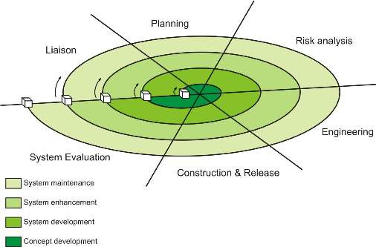

Each of the regions is populated by a series of work tasks that are adapted to the characteristics of the project to be undertake. For small projects, the number of works tasks and their region contains more work tasks that are defined to achieve higher level of formality.

**SYSTEM DESIGN**

**Database screenshots**

**User Table**

This table store the data of all the users that are signing up for getting full access to the website.

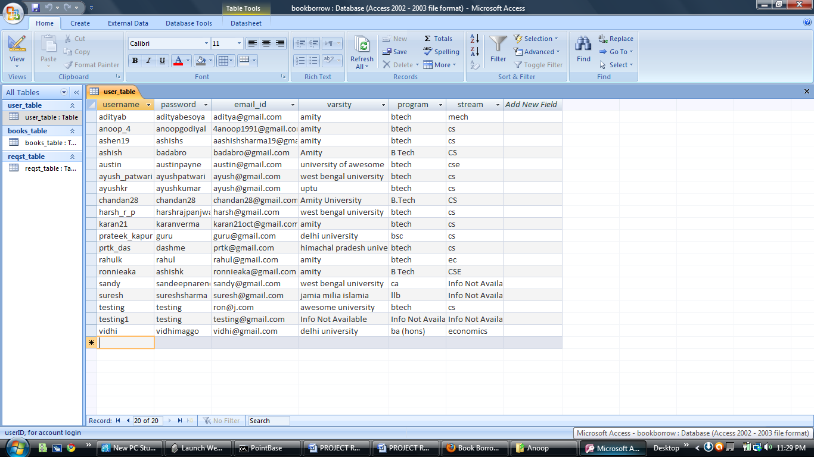

**Books Table**

This table stores all the details of the books available in the repository including book id, title, author name, Publisher, eBook availability etc.

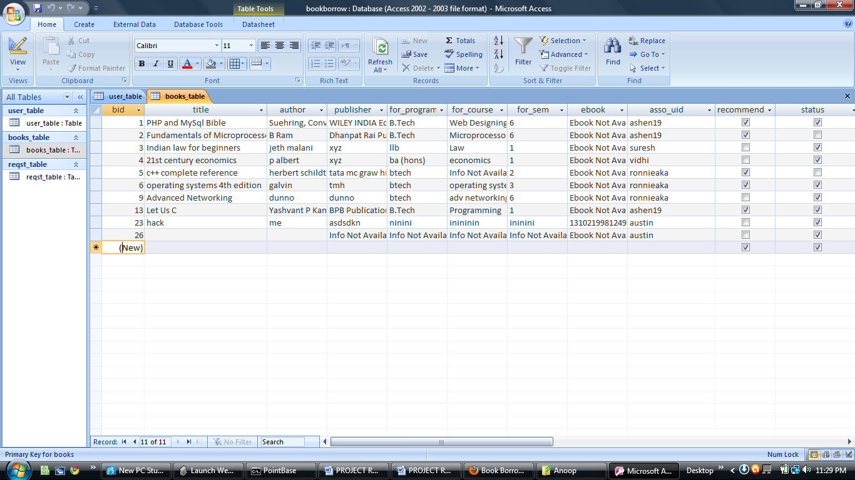

**Book Request Table**

This table stores the information about a particular request along with its processing status. It also contains the request id, book id, name of requester and requirement type.

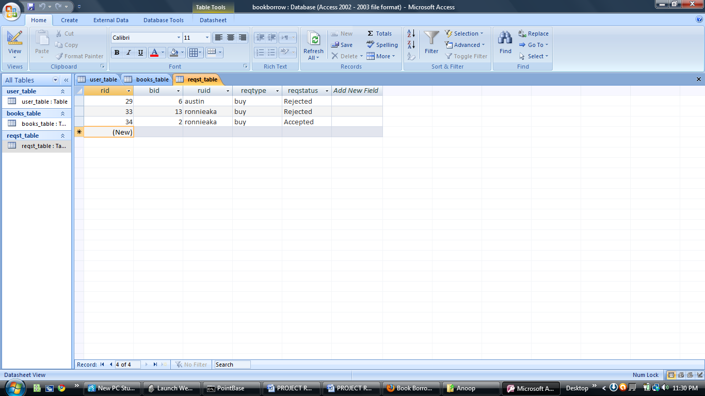

**RESULTS AND DISCUSSIONS**

**SCREENSHOTS**

Home page: This page shows the search bar. The user can search for any book by typing in the name of the book. The page also provides a no. of options like login, sign up etc.

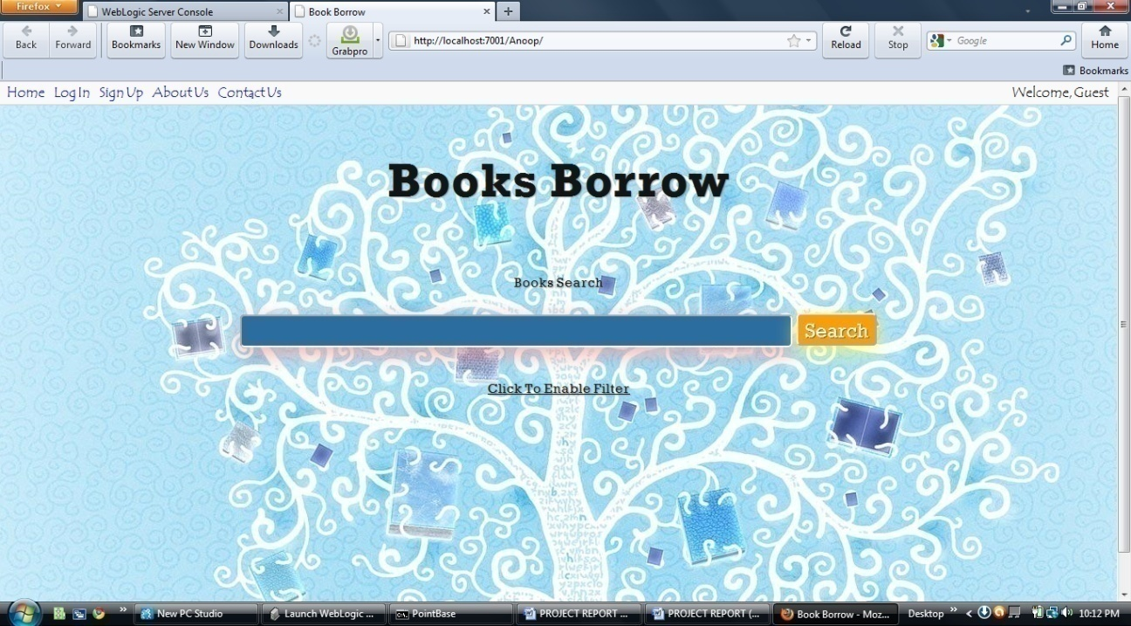

Home Page with enabled filters: The user can search a book with the help of filters such as author name, publisher, course or semester.

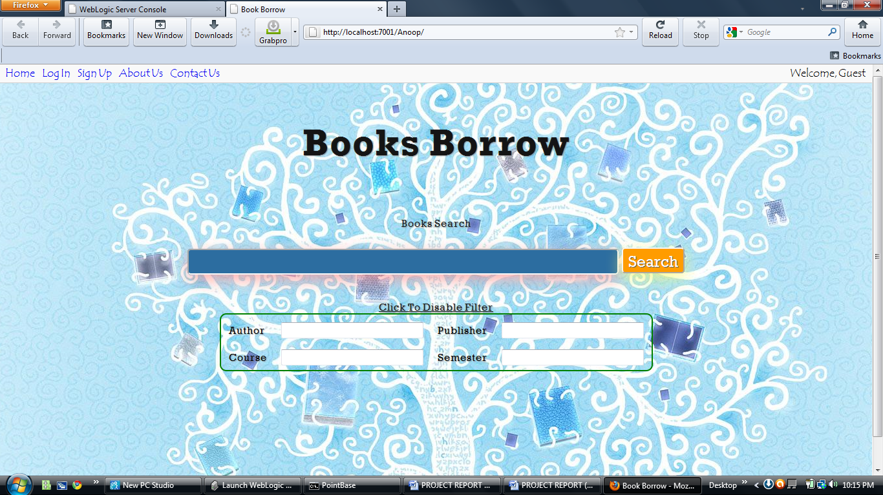

**Login page**: This page is used to authenticate users

* User name and password

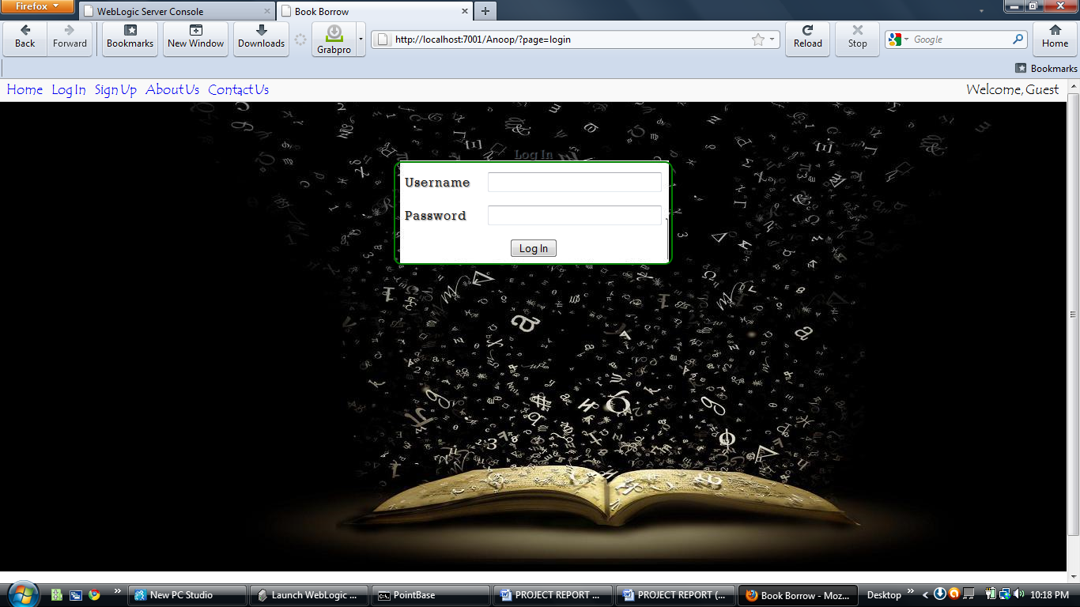

Sign Up Users Page: The user can sign up to get a full access to the features of website.

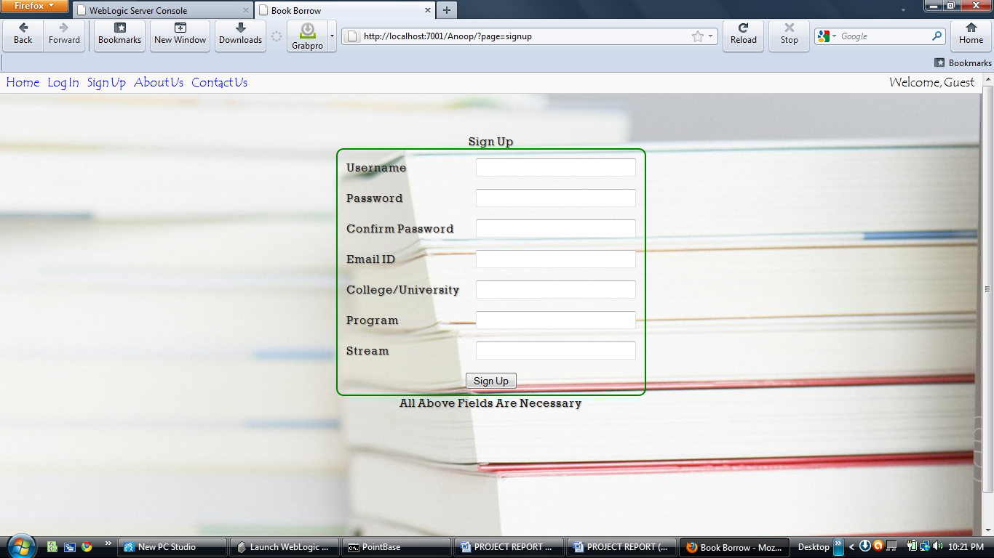

After Signing Up user can add his/her book to the database

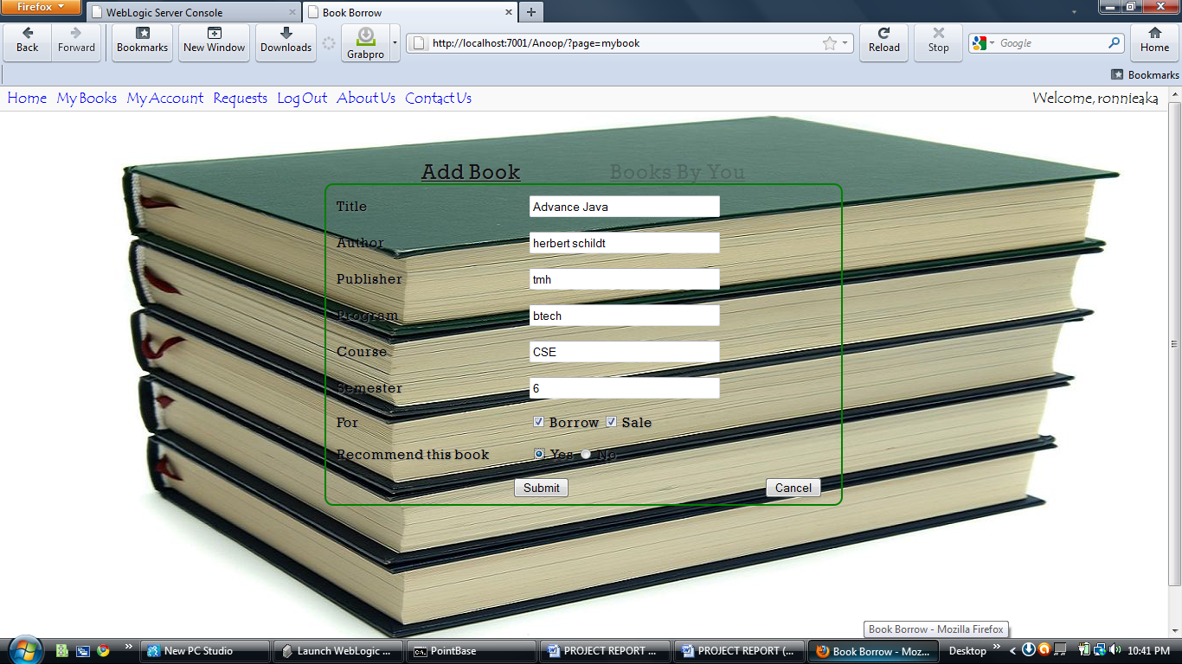

A click on submit button leads the user to a page where he/she can upload an eBook.

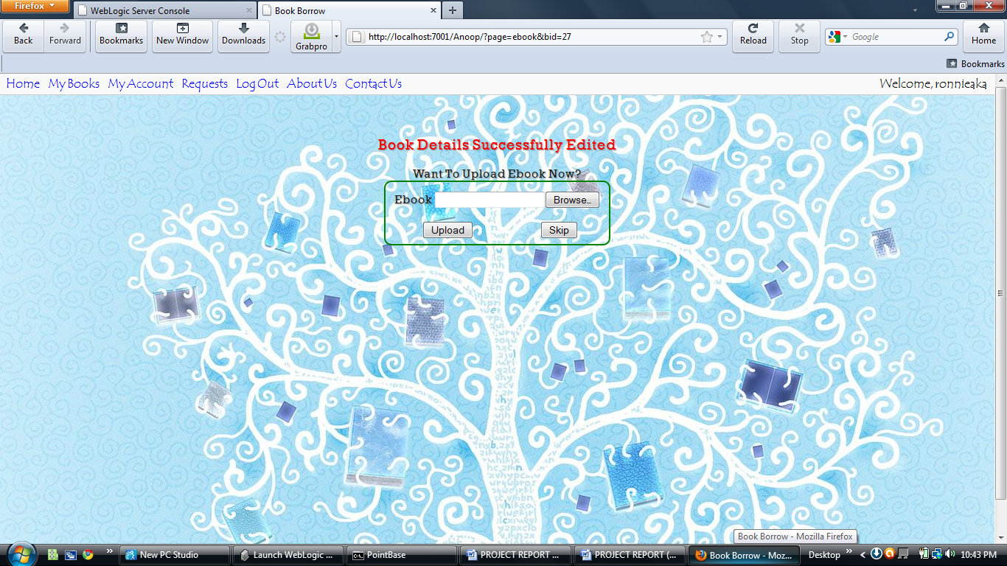

User can view the books he/she has added to the database.

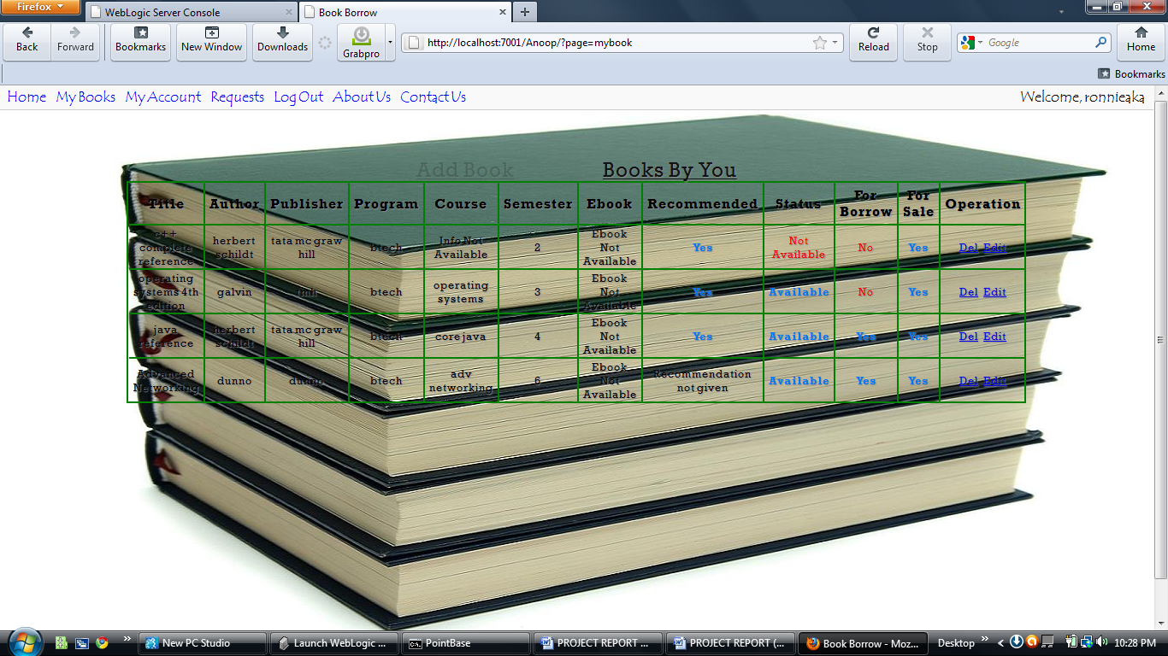

Delete button allows user to delete an entry of his/her book from database.

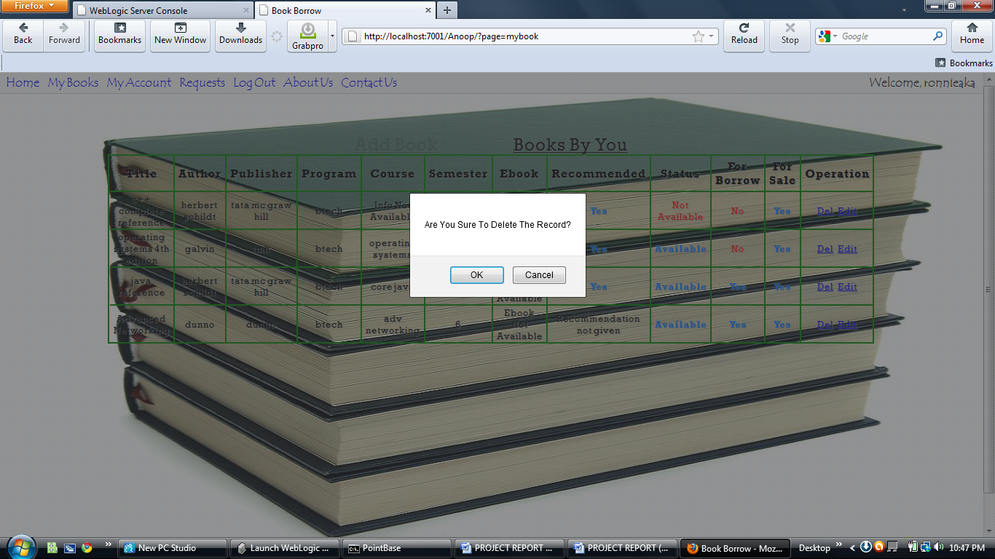

Edit button allows user to edit any details of the books. The changes will be saved to the database

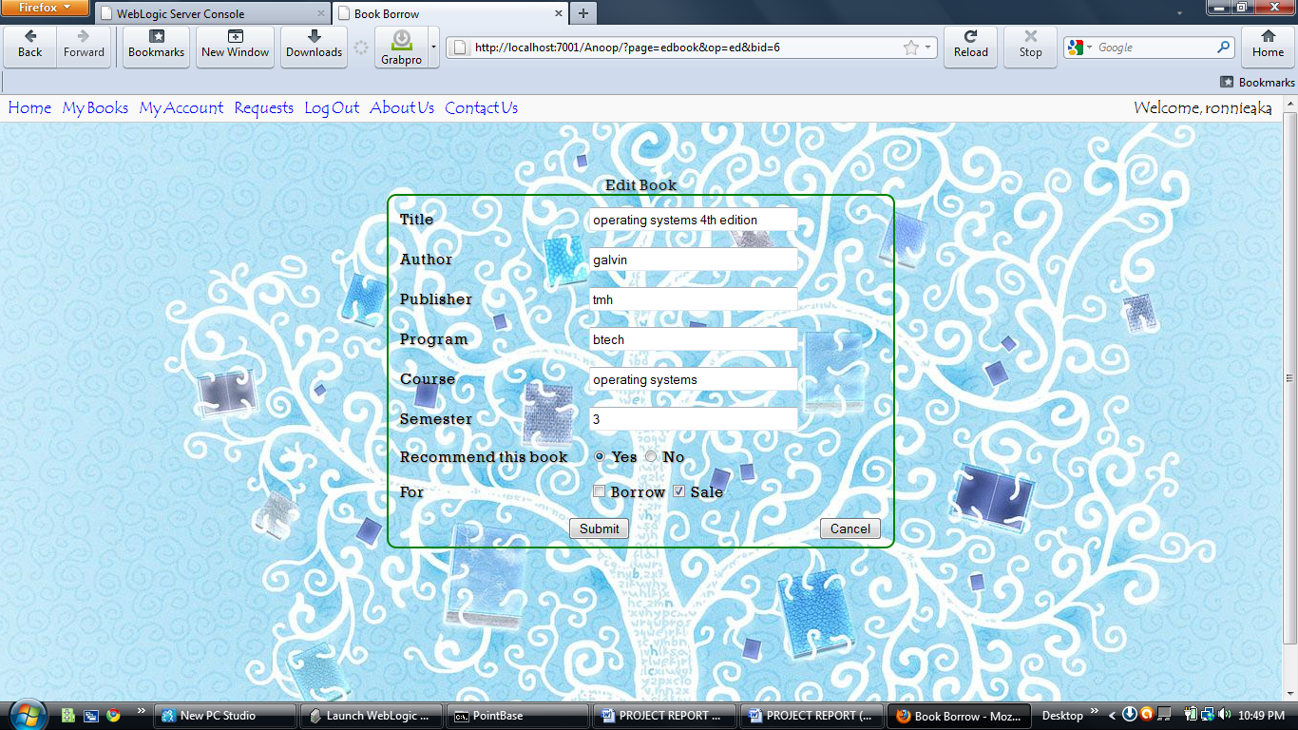

User can update his/her account. Here he/she can change his/her password, email id, college name, Program and stream.

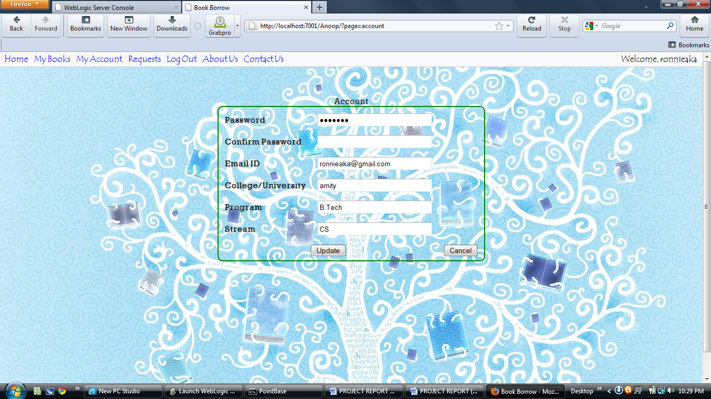

When a user searches a book 2 results are possible:

* Unsuccessful search: A message “Sorry! No Result” is displayed

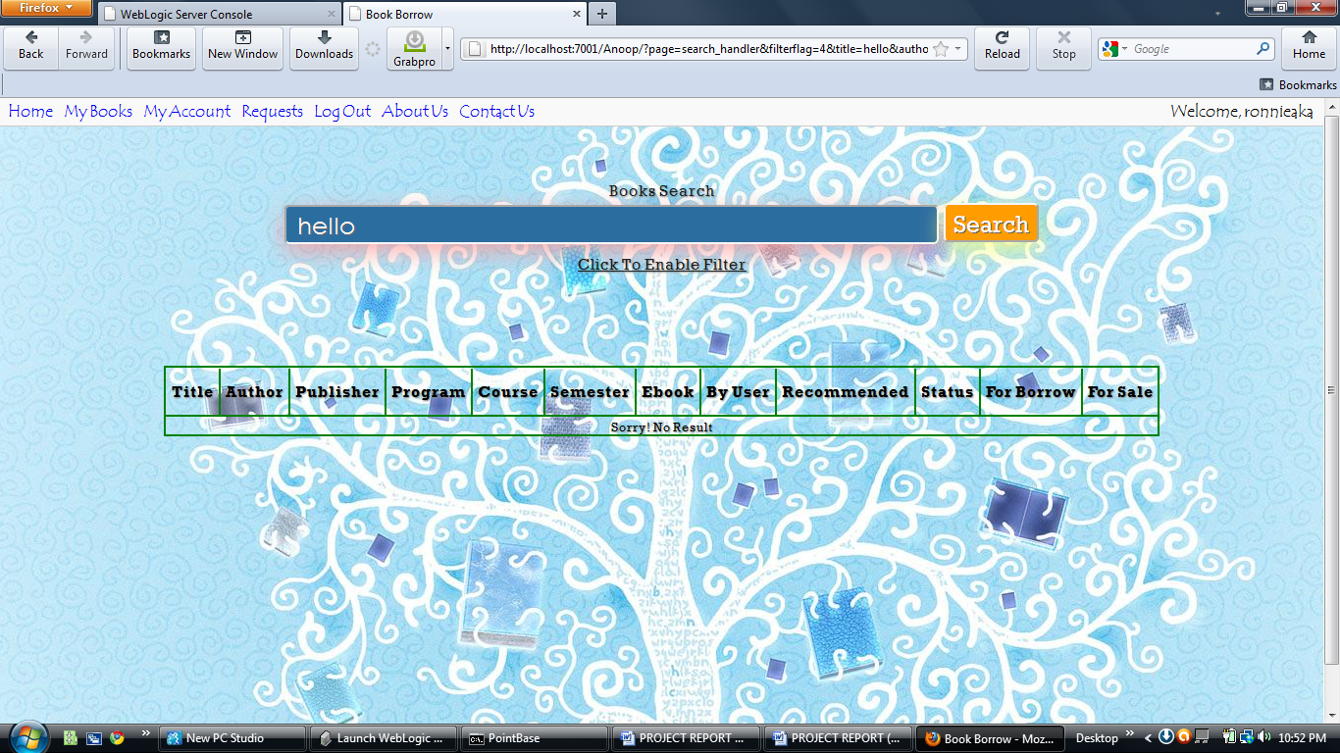

* Successful search: A list of books is displayed.

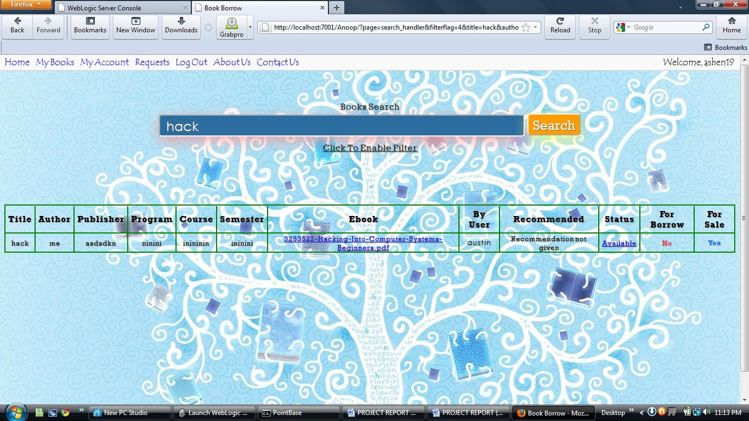

In case of a successful search if user clicks on eBook button, he/she is shown the eBook.

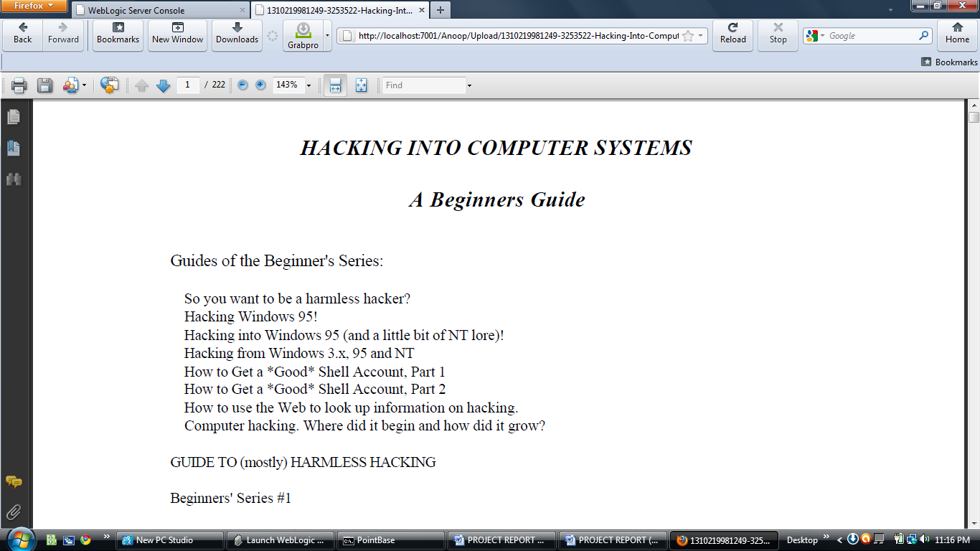

If he/she chooses to click on available button in status tab, the following page is displayed. Now user has an option of buying the book.

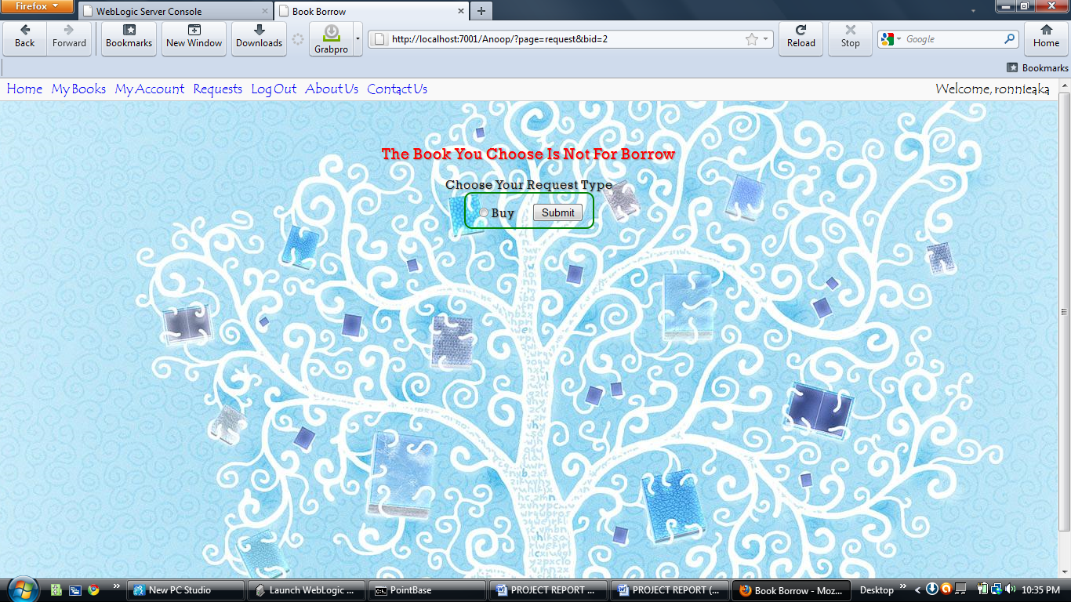

If he/she clicks on submit button the admin tells the user that his/her request is under process.

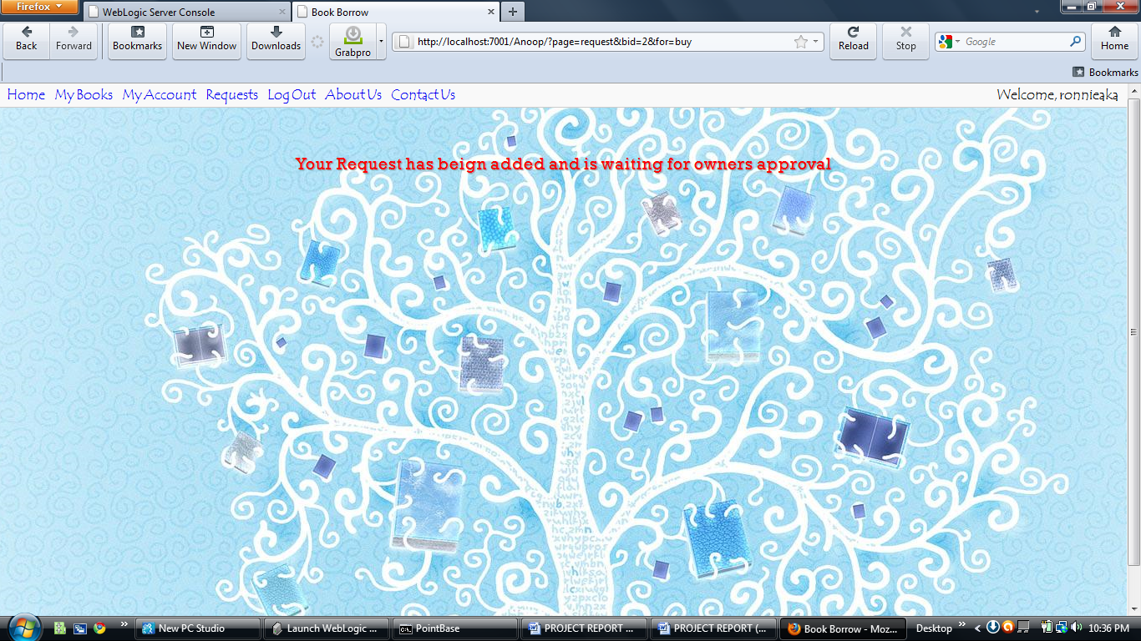

Request page showing user’s requests and request by others

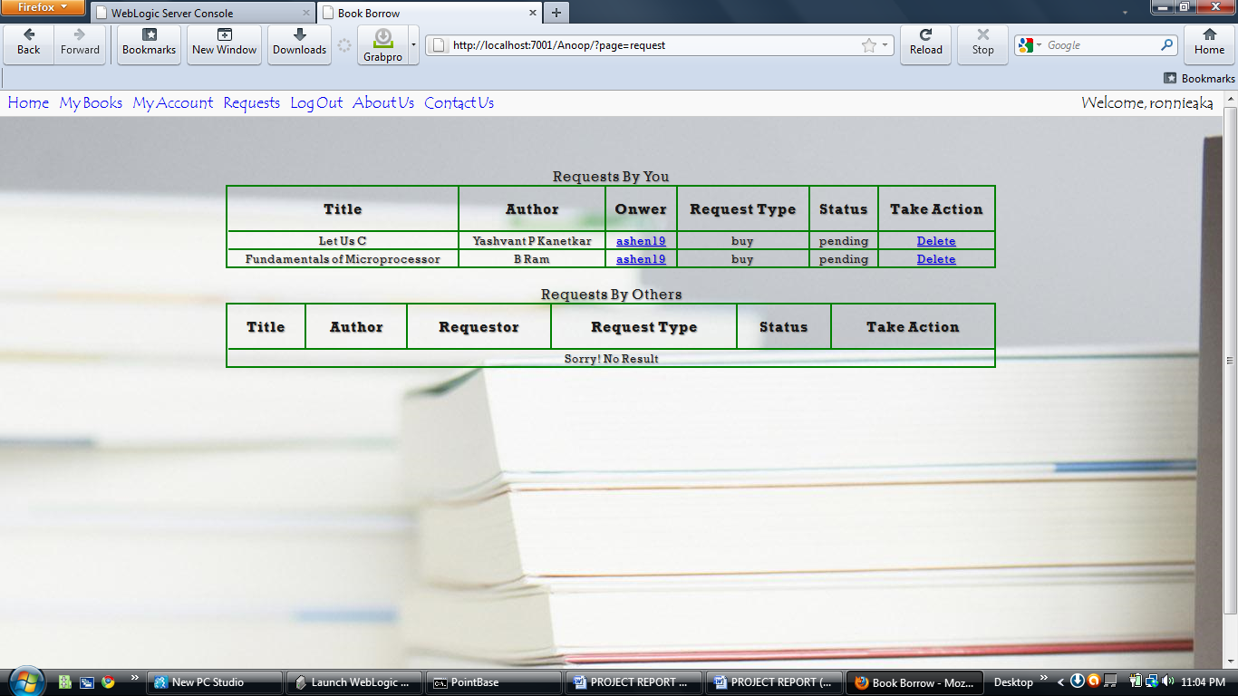

Request page of book owner: This page allows owner to either to accept or reject the requests made by buyers or borrowers.

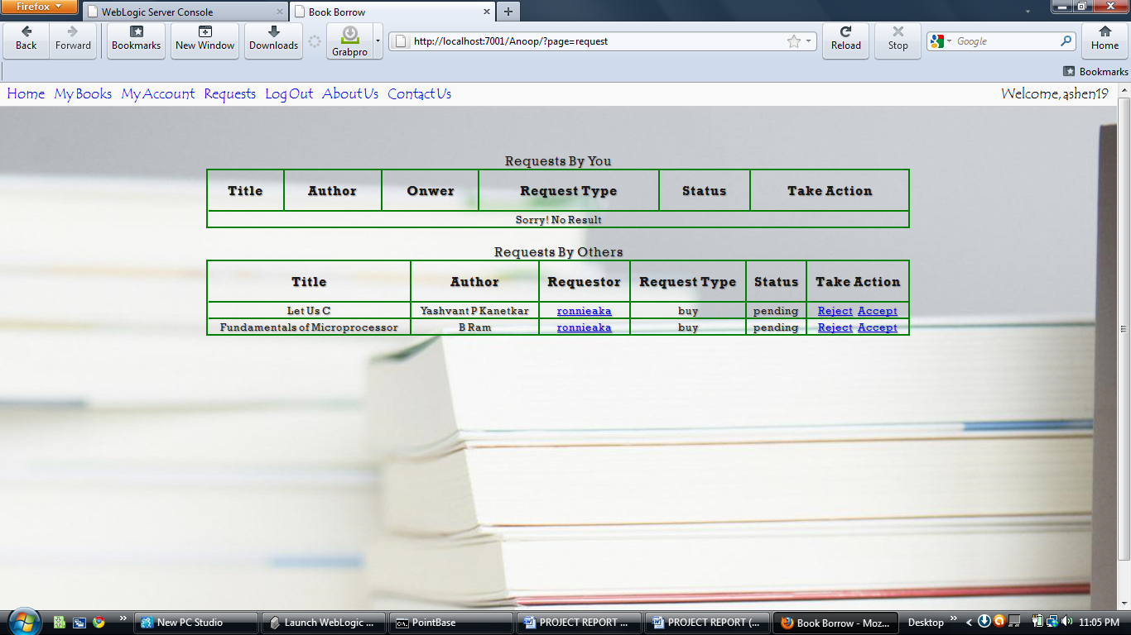

After clicking reject button: Request is rejected and requestor is informed about the rejection.

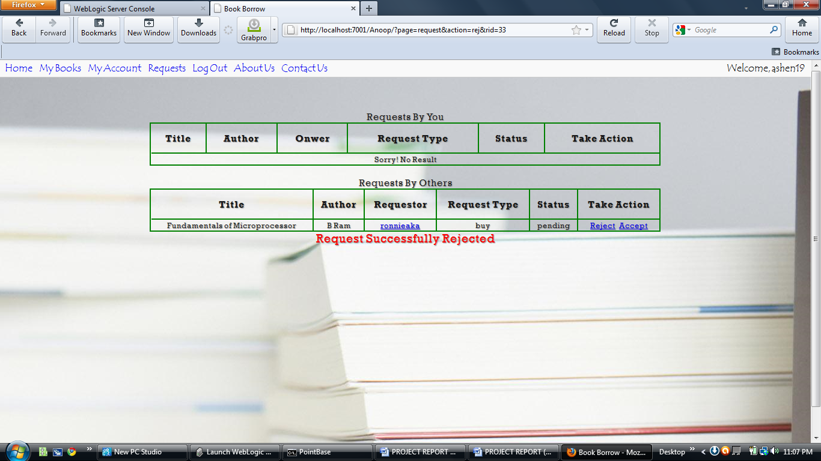

After clicking accept button: Requestor is informed that his/her request has been accepted.

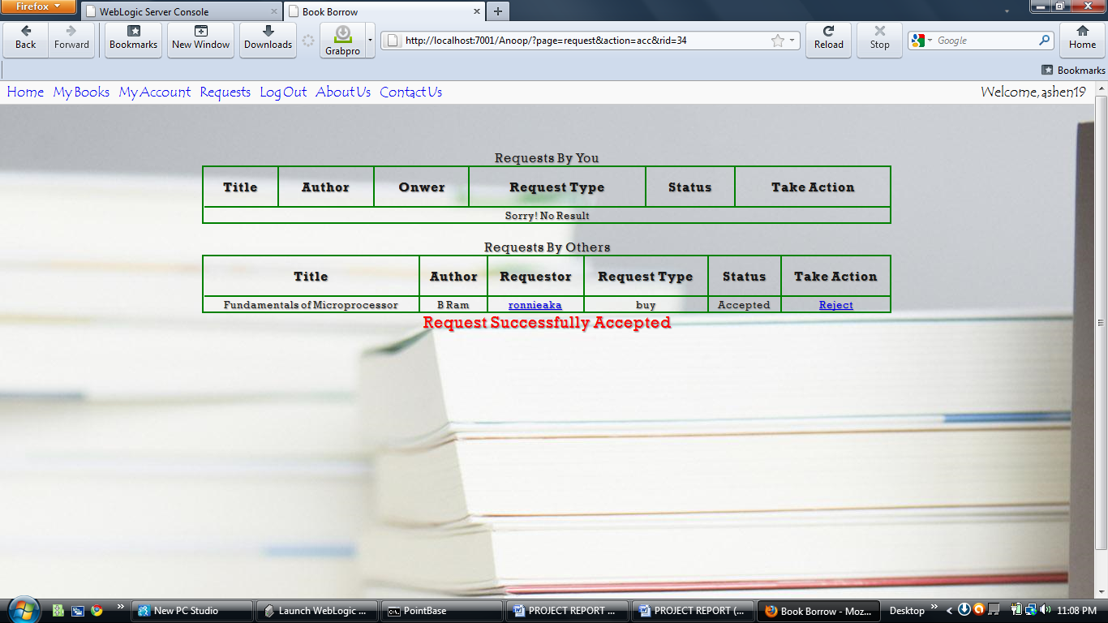

Clicking on requestor button: The owner can gather the information of the requestor to contact him/her for future reference

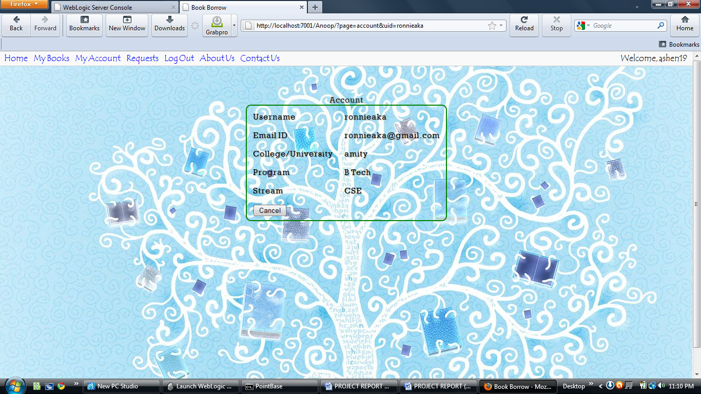

About Us Page

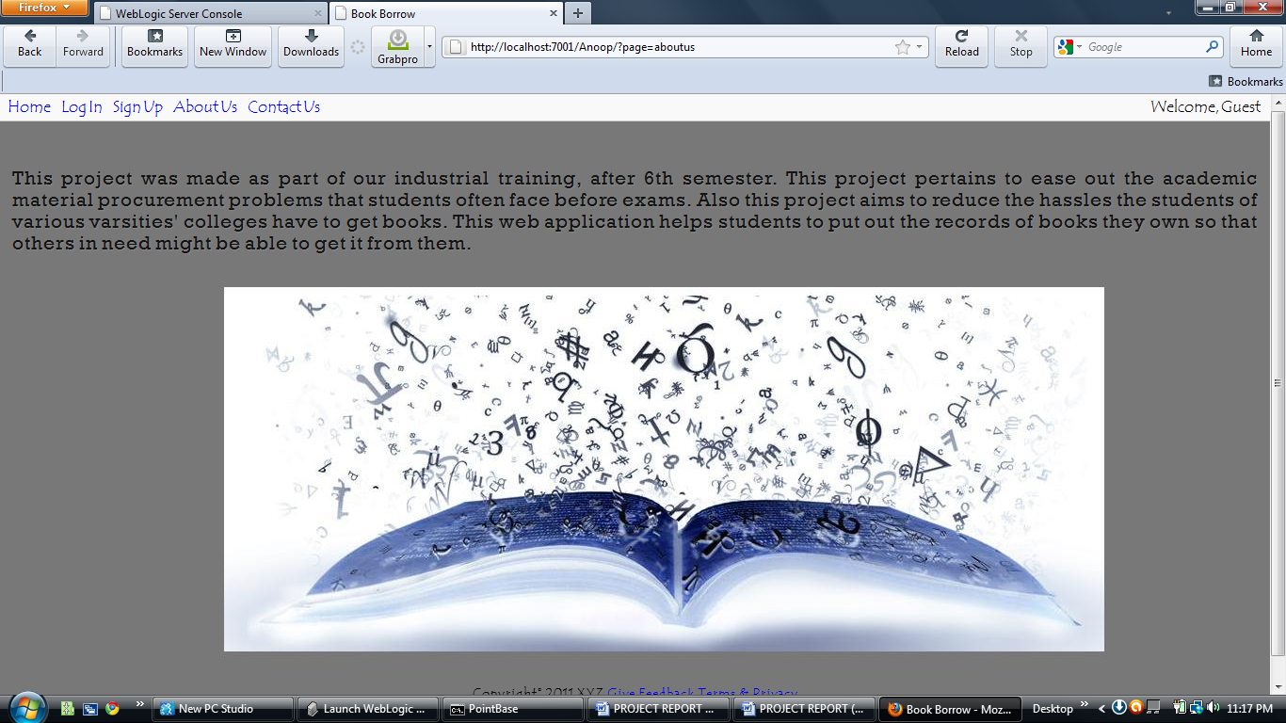

Contact Us Page

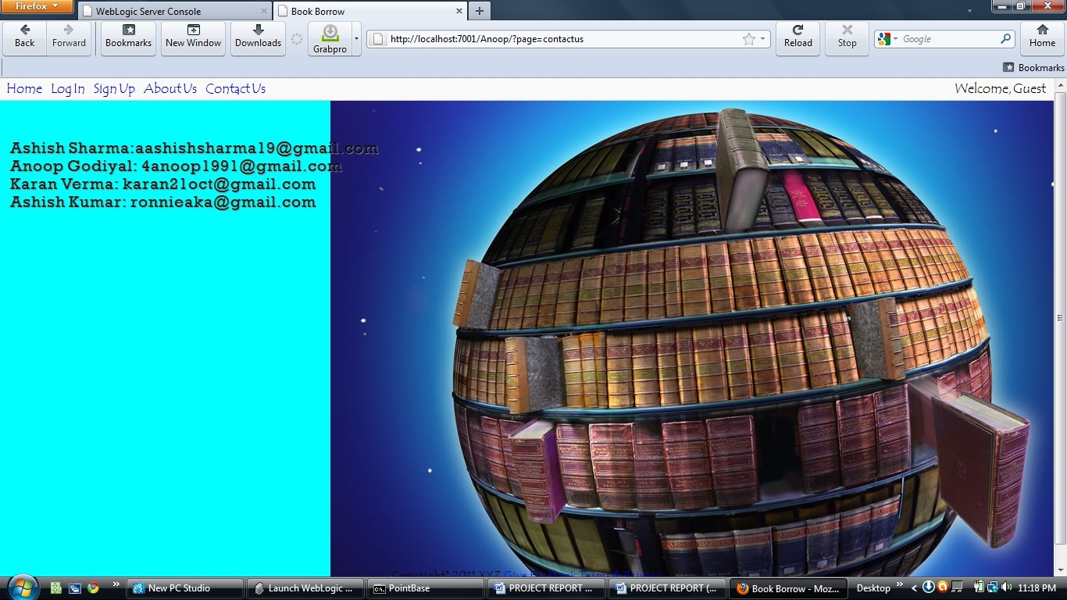

**CONCLUSION**

At the end of the summer training the importance of getting to know about working in a corporate environment and how projects are handled at enterprise level was taken into realization and it was a beneficial experience

Use of various Advanced Java technologies like JSP and Servlets was learned and also databases like MySql and MS Access. Various useful things can be done with these technologies in a variety of ways, to make better, efficient, useful e-alternatives to real world methodologies of getting things done, like for example, getting book borrow or purchase deals online at the ease of a click without all the hassles of going to a bookshop. The project’s aim to provide a repository for books of students of universities which allows them to be shared was achieved. This project provided an opportunity to delve into the finer practical aspects of the advanced Java technology and use them for better efficiency and manageability of the project.

The project provides a useful and practical solution to the problem of procuring academic study material easily by simply searching for the books/notes one needs, with additional filters to help search for the books accurately and a facility of requesting books by two options – buy or borrow. Also there is a facility for uploading e-books which makes sharing course books easier as e-books can be downloaded and hence procured faster than hardcover books.

**IMPLICATIONS FOR FUTURE WORK**

For further improvements in this project, new useful features could be added in the future to make this project more useful, such as

* More search filters,
* Sorting of results,
* Better display of search results, like in Google,
* Bookmarking of favorite books, and users,
* Comments, ratings and reviews on books,
* Email notifications of requests via jsp email plug-in from server side to client’s email,
* Autosuggestions feature in search,
* A chat system for users to interact amongst themselves,
* Public requests page, to post requests for books which no user has but can get later on after reading the request,
* Integration of Open ID to make login hassle free for new users,
* Captcha assisted human verification in signup form,
* Recover password facility,
* More security,
* Better interface with CSS3 and AJAX

**BIBLOGRAPIC & REFERENCES**

1. COMPLETE REFERENCE BOOK (ADVANCE JAVA)
2. HEAD FIRST BOOK (ADVANCE JAVA)
3. SUN MICROSYSTEM BOOK (ADVANCE JAVA)
4. HCL INFOSYSTEMS BOOK (ADVANCE JAVA)
5. www.java.sun.com
6. [www.w3schools.com](http://www.w3schools.com)